**Quick Start Tutorials: How to compile an Agent**

If you are using **Eclipse**, the agent file is often compiled automatically and can be found in the “bin” folder in your workspace. If the file has not been compiled automatically, you can compile it by selecting **project🡪 Clean…** (see figure__).

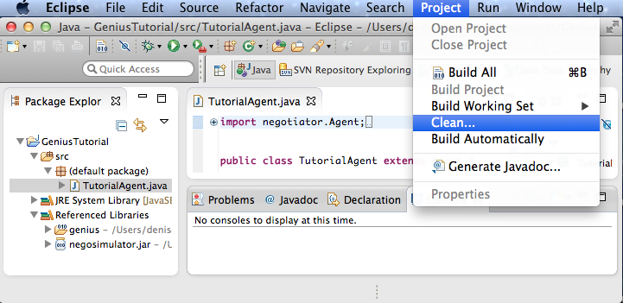

To manually compile the agent, first, place the agent java file (ex. TutorialAgent.java**)** in the directory containing the **negotiator.jar** file**.** Then, in the computer’s Terminal enter the command line: **javac -cp negosimulator.jar YourAgent.java**

Move the agent .class file into the **genius** folder. In order for Genius to recognize your agent, you have to recreate the directory structure of your Java package. For example, if you have a project with a package “agents” in which the agent .class file is located, then the agent should be moved in a folder “agents” in the root of your Genius installation. An agent may consist of multiple class files. Now we can add the agent in one of the following two ways:

* **Load the agent using the GUI:** An agent can be easily added by going to the “Agents” tab in the “Components Window” (see Figure 13). Next, pressing right click opens a popup with the option to add a new agent. The final step is to select the main class of your agent.  Figure 13: Adding an agent using the GUI.

